

Final Project

Topic: Restaurant Management

Lecturer : Lypengleang Seang

Course: Dynamic Web App

Year: III

Semester : II

Academic Year : 2019 – 2020

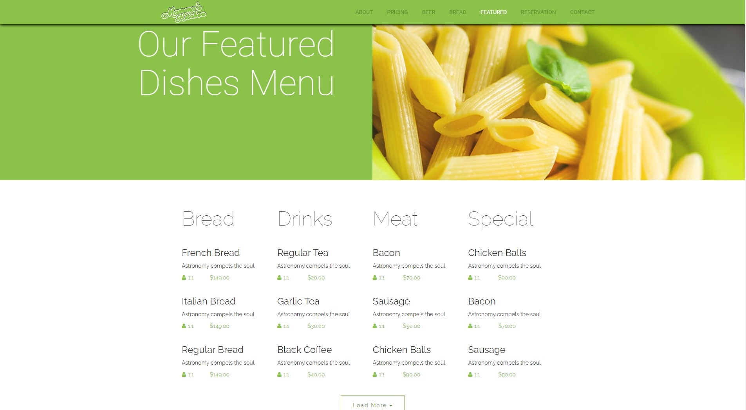

By Group Member :
Mr. Oum Soknang(Leader)
Mr. Norn Sokun(Deputy)
Ms. Roeuy kay
Mr. Neang Sovannthai
Ms. Duong Dara
Mr. Chhay Lang

Date : 10 / 11 / 2020

Dynamic Web Development Report

Week I

What is the project about?

- This system is about Restaurant Management, An online food ordering system service are website that feature interactive menus allowing customer to place orders with local restaurants and food cooperatives.

Why we choose this topic?

+ We choose this topic for 2 main reasons:
1, Problem: Difficult for to find best food and some restaurant are full of customers
2, Solution: This system give us many advantages such as save more time, could get more information about foods in our restaurant, can book foods online, could select any foods you like.

What is our goal of making this happen?

Our Goal:
Online food ordering and sit booking system is bridging the gap between small restaurants and their customers. Restauranteur can enhance restaurants booking system with amazing features offered by website.

How my team build this platform?
we use PHP Framework called “Laravel” for our platform and we device into 2 platforms such as:
- Frontend: to let customer to see list of foods and information about restaurant such as menu and price.
- Backend: for restaurant admin to post menu foods, famous foods, price and information about restaurant and foods.
We have devise tasks to team members such as:
Oum Soknang:
- Team leader and full stack
Norn Sokkun:
- Team Deputy
- Create database structure and manage on database
Neang Sovannthai
- Create UI
Duong Dara
- Coding crud
- Do report
Ruoey Kay
- Coding crud
- Do slide
Chhay Lang
- Coding crud

Firstly, we use old project “Restaurant Management” that it already has frontend and backend by using php for develop and now we upgrade into php framework called “Laravel”. First step we create project by run comment to create Laravel project and keep using php platforms. Beside all of these, we also find some more ways to help for improve our project by research more on the internet such as some coding website and watch YouTube tutorials.

Week II
We have updated some interface and connect our project with database.
This is our sitemap:

Site Map :
Restaurant Management

Frontend
Home Page
Backend
Menu
Slide show
Popular Product
Breakfast
Lunch
Friendly support
Email
About Us
Phone Number
Dinner
Social Media
About
Contact
Reservation
Update
Request List
Cate List
List
Delete
Reservation
Categories
Add
Add
Update
Contact
Dashboard
Food Item
Categories
Reservation
Delete

Database Structure
- Tables Relationship Structure
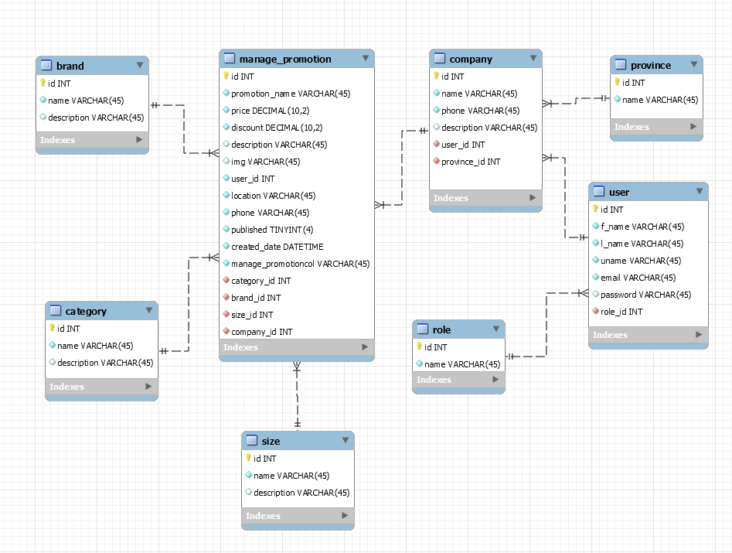

Our Platform
- Frontend
- About us page
………………

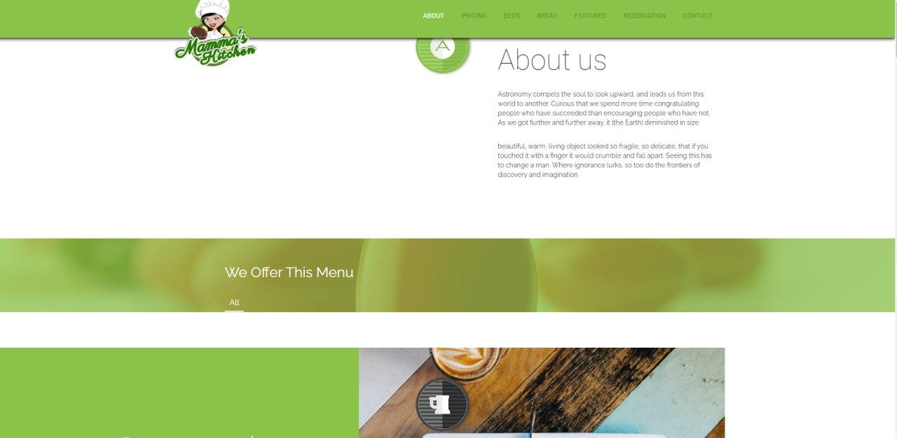

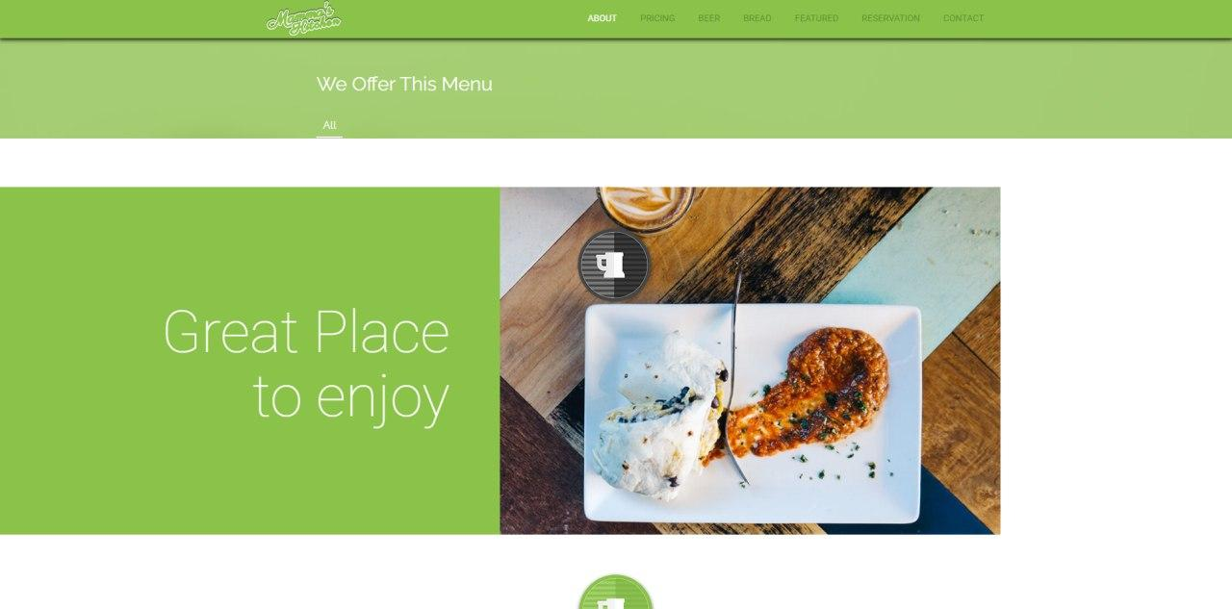

- Beer page
…………………

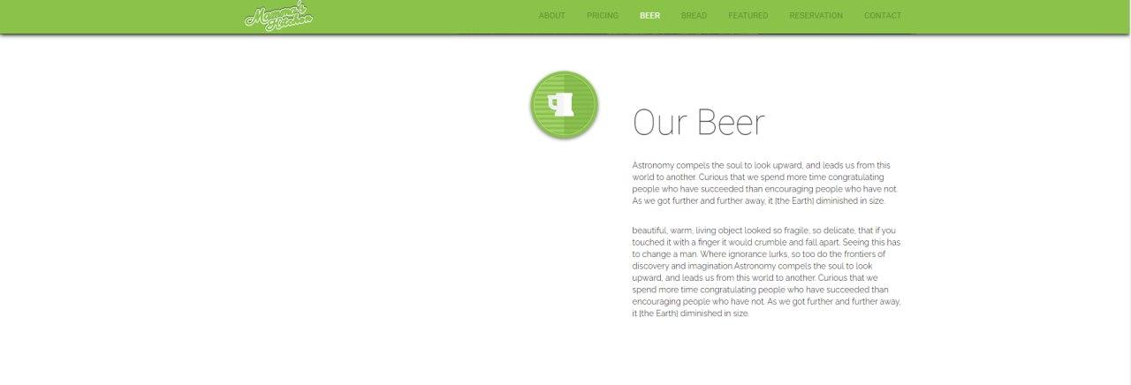

- Feature page
……………………

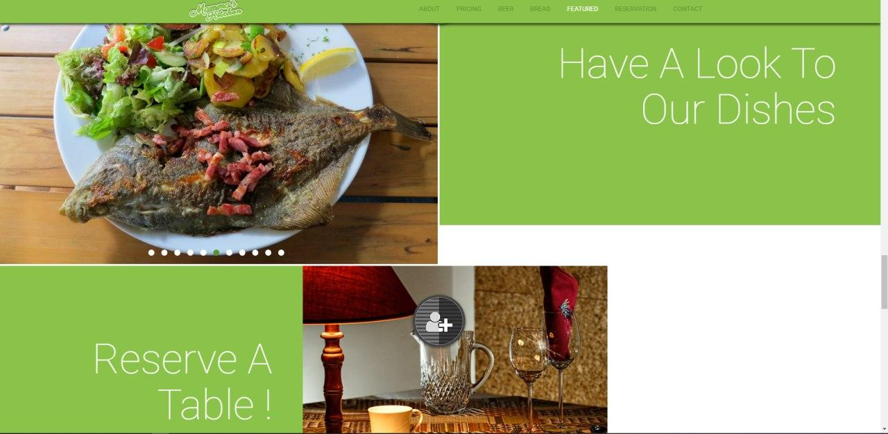

- Reservation page
……………………….

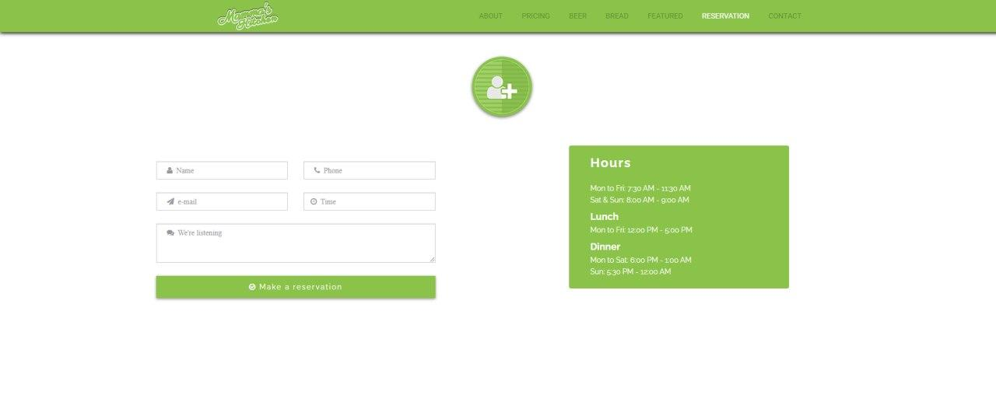

- Contact page
……………………………..

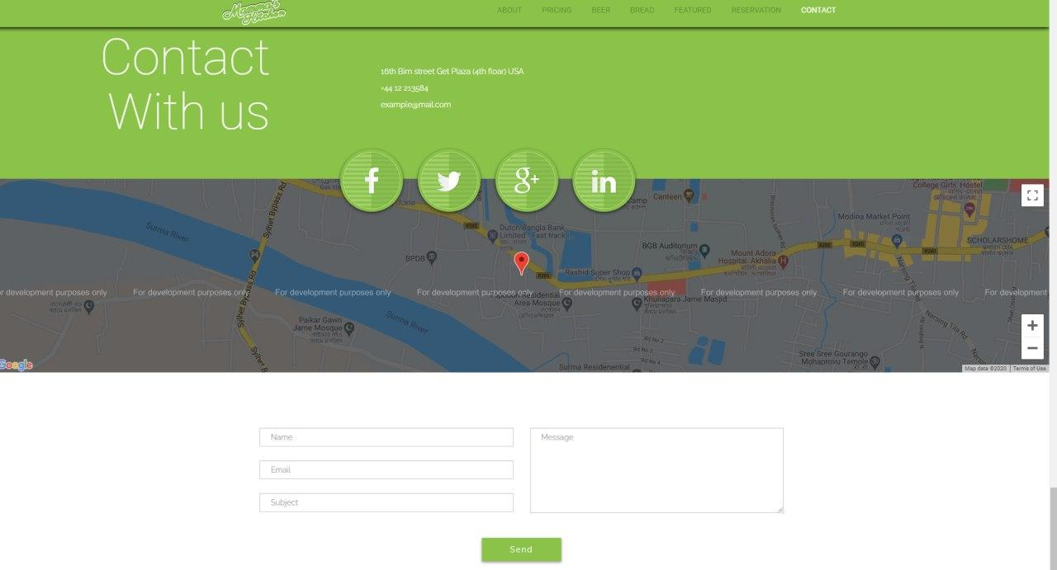

+ Backend

- Dashboard
…………………………….
+ Configuration
- Installation
……………………………
- Frontend
…………………………….
+ website references and YouTube link
………………………………….

